Refurbishment of External Cladding at Sainsbury’s Store

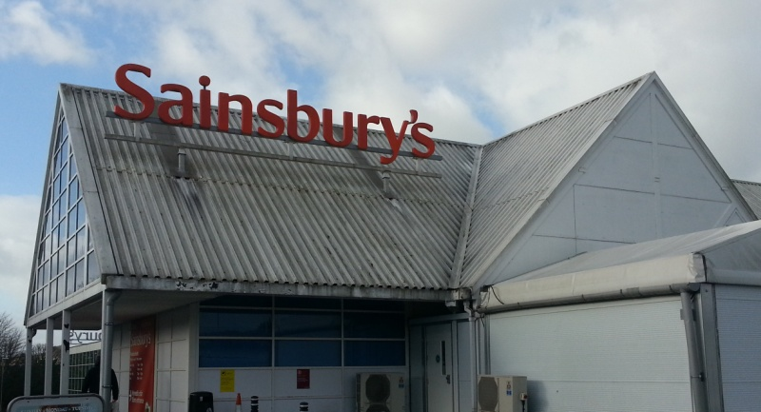

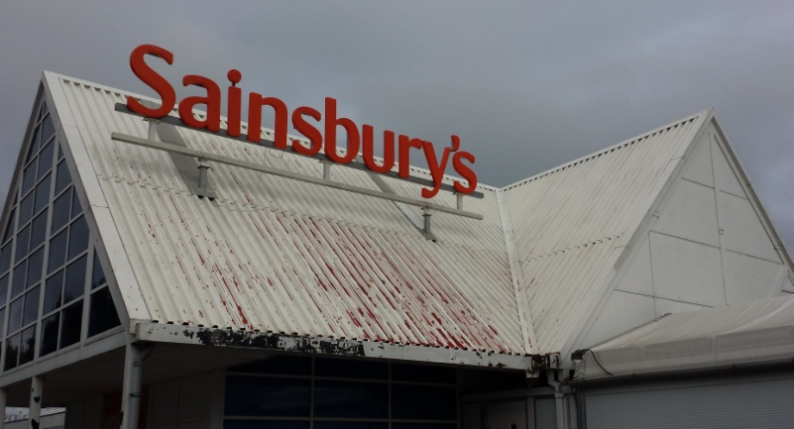

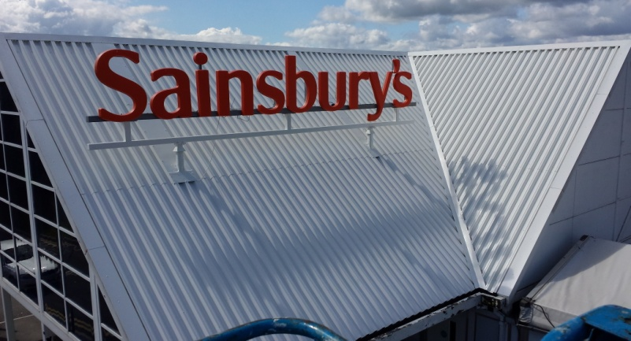

We were asked by ISG retail to refurbish the external cladding of the Sainsbury’s store in Pontllanfraith, as approved Akzo Nobel Steelseal contractors we secured the contract and completed the works within a very tight timeframe, as a working store we had to liaise with the client and the store management in order to work around the general public and store opening hours, in addition to the cladding we also refurbished a number of staircases and railings to the rear of the store

Contract: Envelope Refurbishment

Contractor: ISG Retail

Location Pontllanfraith

Duration: 6 weeks